Step1-> Run sonar container in docker desktop in VM

Step2-> open localhost:9000/

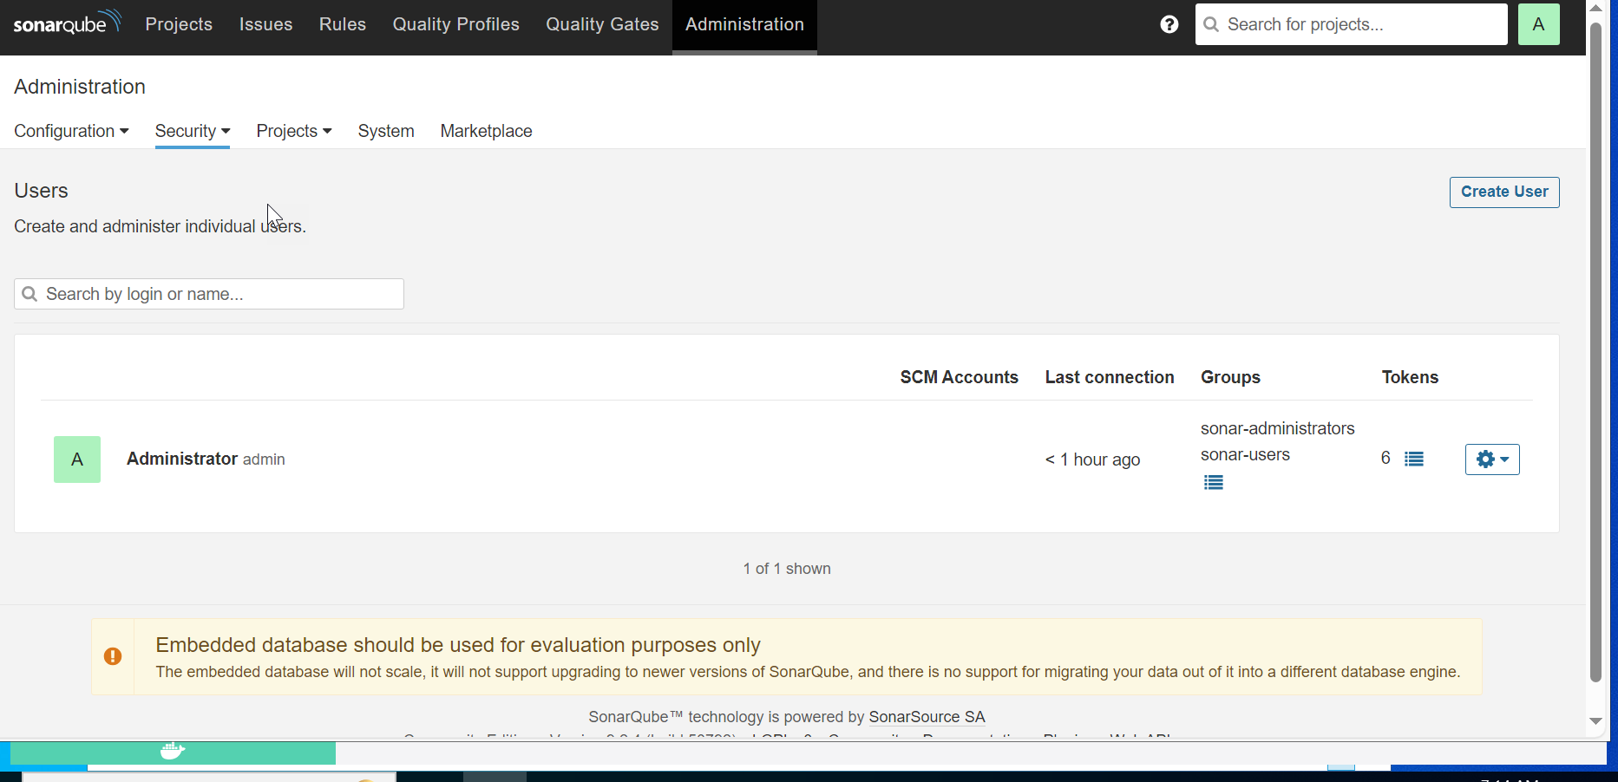

Administration-> security->users-> tokens->

Generate token and save in notepad for logging.

This token has to be provided Jenkinsfile in Sonar stage.